Personal Branding Suit
Visual Biography
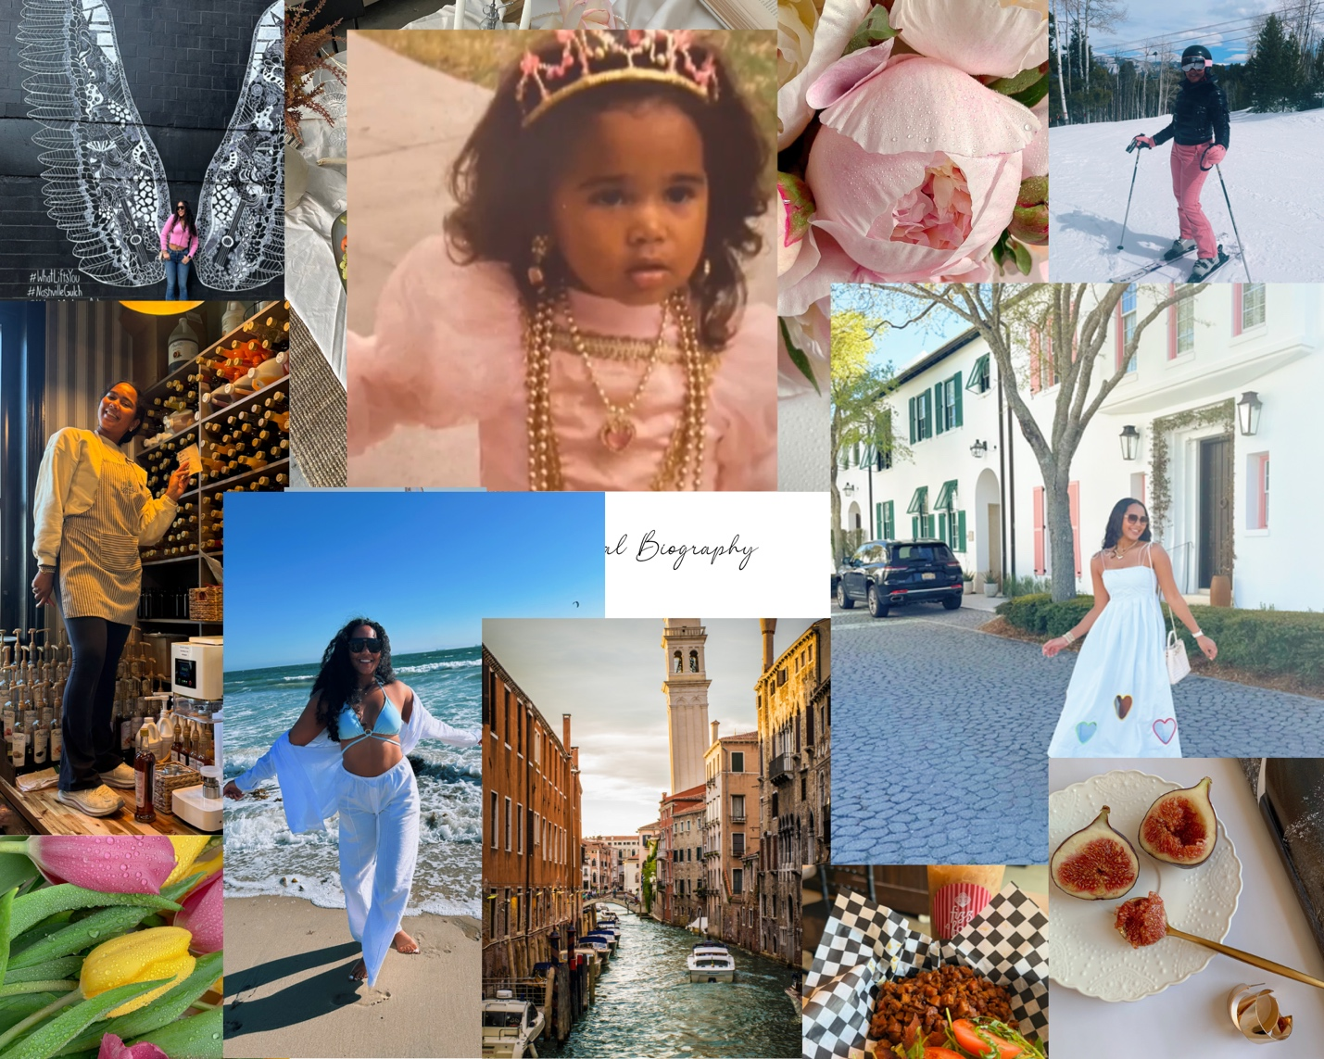

LinkedIn Header


Website Banner


Email Signature


Business Card
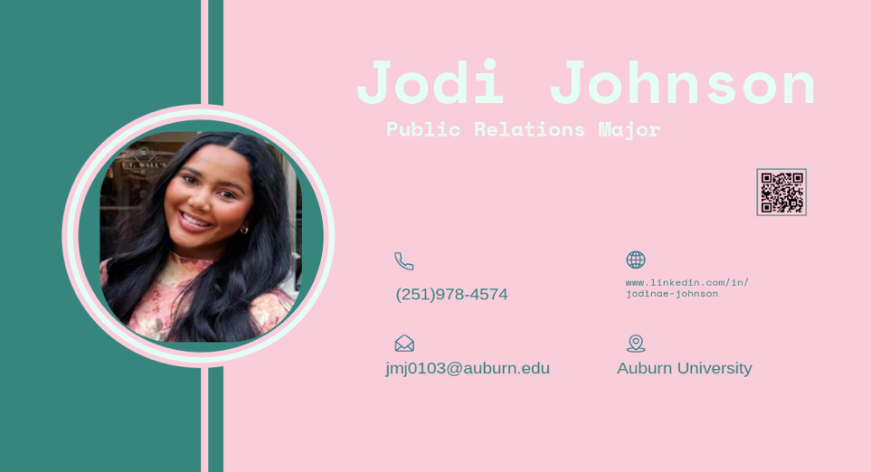

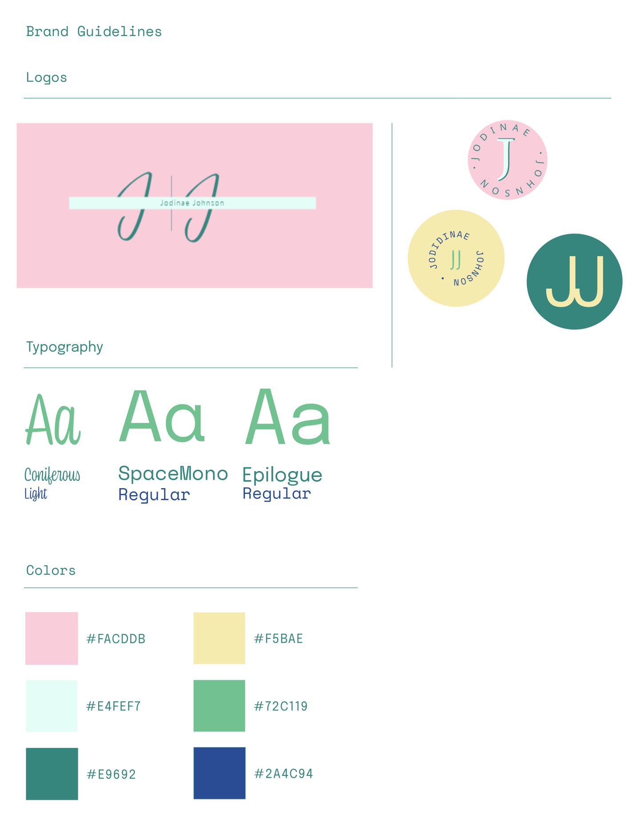

Rationale
The objective of my personal branding suite was to create a cohesive and visually compelling identity that reflects who I am as a public relations student at Auburn University. I wanted my brand to communicate both creativity and professionalism, while also highlighting my attention to detail and ability to think strategically about design and messaging.
My target audience includes potential employers, internship recruiters, and professionals in the public relations and communications industry. Because of this, I focused on creating a clean, polished, and modern brand that would stand out while still maintaining a professional tone. I also wanted my brand to feel approachable and personal, which is reflected in my use of soft colors and a script-style logo.
My branding suite includes a brand kit, visual biography, website banner, LinkedIn header, business card, and email signature. Each element was designed to work together and create a consistent identity across platforms. I used a pastel color palette featuring blush pink, mint green, and soft yellow to create a feminine yet professional aesthetic. These colors help establish a cohesive look while also making the brand visually appealing.
In terms of typography, I used Coniferous Light as an accent script font to add personality and individuality to my brand, while Space Mono Regular and Epilogue Regular were used for headings and body text to ensure readability and structure. This combination creates contrast and balance between decorative and functional elements.
I focused heavily on the principles of design, including contrast, alignment, repetition, balance and the use of negative space. For example, I used contrast between light backgrounds and darker text to improve readability and draw attention to key elements. Alignment and spacing were carefully considered to create a clean and organized layout, while repetition of colors, fonts and logo styles helped reinforce brand consistency. The use of negative space throughout my designs allowed the content to feel uncluttered and visually balanced.
I used Adobe Illustrator to create my logo variations and business card, Adobe InDesign to design my brand guidelines and visual biography and Adobe Express for formatting and exporting some of the final elements. Using multiple Adobe programs allowed me to ensure both creativity and precision across all components of my branding suite.
During peer review, I discussed my color palette, typography choices and overall layout with my partner. Based on this feedback, I refined my alignment, improved spacing and simplified certain design elements to create a more cohesive and professional final product.
Overall, this branding suite reflects my personal identity as a driven, detail-oriented public relations student. It provides a strong foundation for my professional portfolio and helps position me as a competitive candidate in the job market.

Peer Comments
Center Name on Logo
Fix font
Spelling error

